# Colorful ultrasound

## 一、Learning objectives

In this course, we will learn how to use STM32F103RCT6 to control colorful ultrasound

## 二、Prepare before class

The hardware required is several DuPont lines, STM32F103RCT6 development board, and colorful ultrasound.

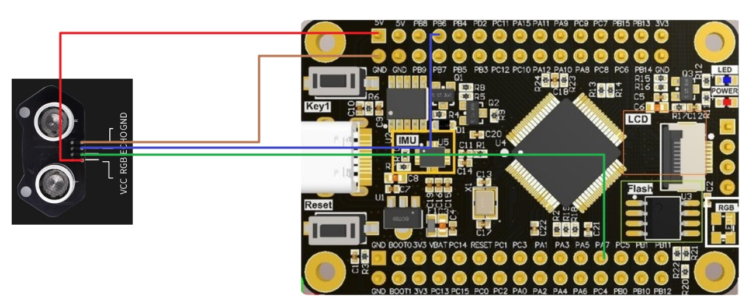

|  |  |
| --- | --- |
| Colorful ultrasound | STM32F103RCT6 |
| VCC | 5V |
| RGB | PA7 |
| ECHO | PB6 |
| GND | GND |

# ultrasound

## 1. Code interpretation

1. Ultrasonic trigger and receive pin initialization 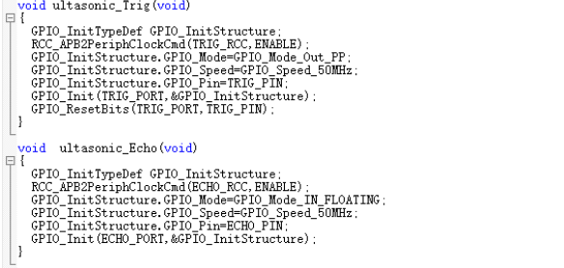
2. Ultrasound acquisition distance function

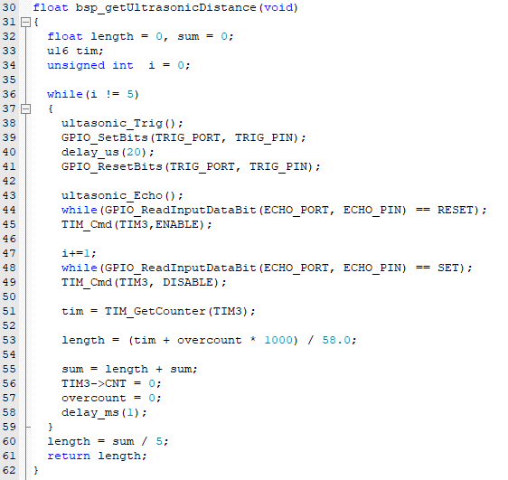

1. Timer initialization

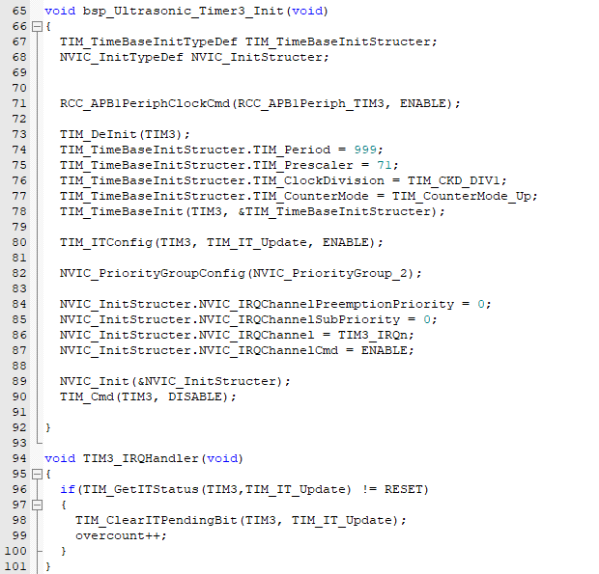

## 2. Experimental phenomenon

After flashing the program, press the reset key, and the baud rate is 9600. The serial port shows the ultrasonic ranging distance.

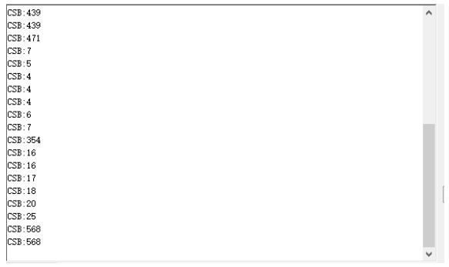

# RGB lamps

## 1. Code interpretation

1. GPIO PA7 initialization

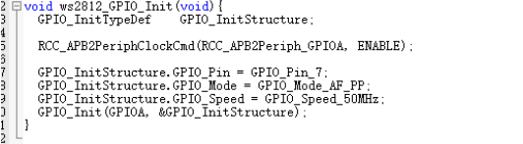

1. Ws2812 initialization

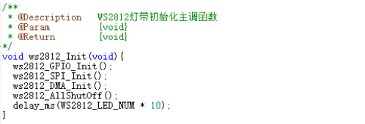

1. Breathing lamp implementation function

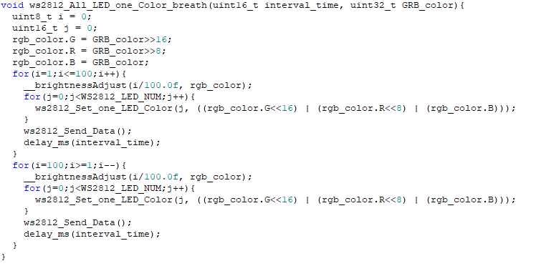

1. The marquee implementation function

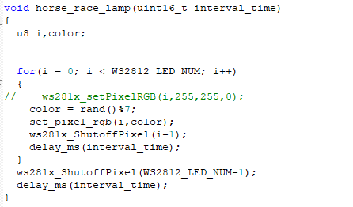

1. The flow light implements the function

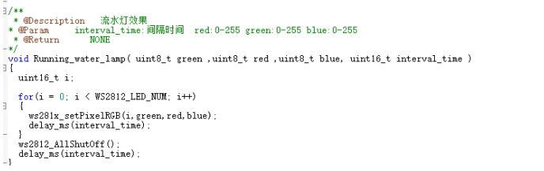

1. 点亮所有灯

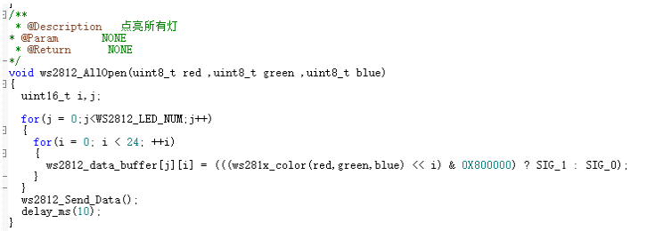

1. 随机点亮一个灯

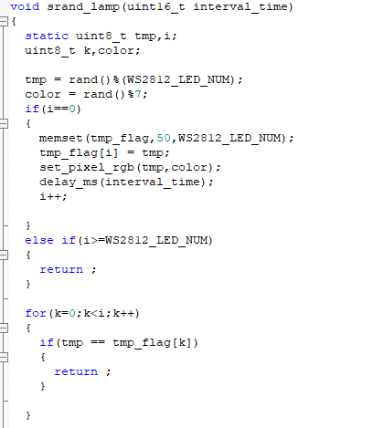

## 2. Experimental phenomenon

After flashing the program, press the reset key; Colorful ultrasound achieves different RGB effects.

